Python for Data Science

**Question 1:** Display Python on the Top left of the image and Data Science on the bottom left. Please take a screen shot of the answer, and upload an image file.

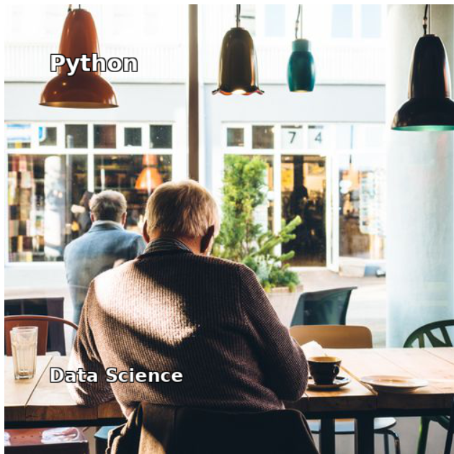v

**Question 2:** Please take a screenshot of the HTML outputs, and upload it as an image. You do not need to take the entire HTML outputs.

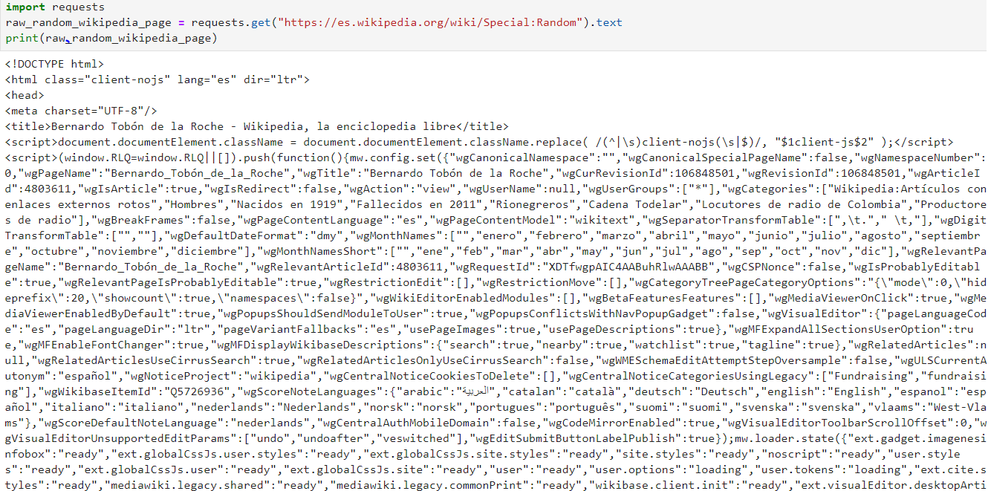

**Question 3**Use the title of the Wikipedia article as the title of the band. The title of the article is surrounded by the HTML tag title as follows:**<title>title - Wikipedia</title>** you must also eliminate the term Wikipedia , Please take a screenshot on your **code** **and** **outputs**, and upload it as an image. (1 mark for partial completion ).

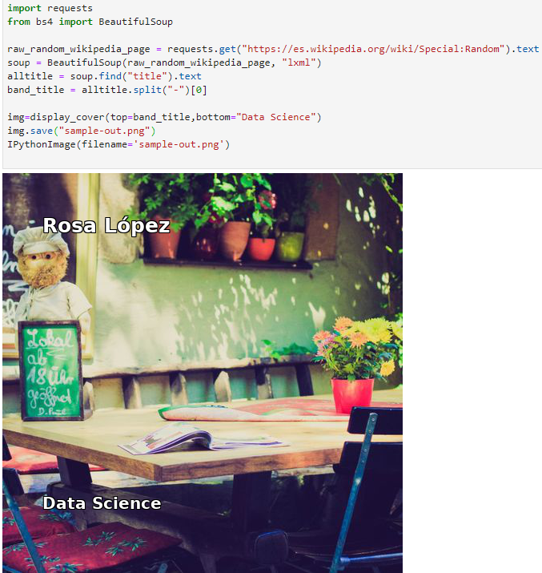

**Question 4:** Use the title of the Wikipedia article as the title of the album . The title of the article is surrounded by the HTML tag title as follows:**<title>title - Wikipedia</title>** you must also eliminate the term Wikipedia . Please take a screenshot on your **code** **and** **outputs**, and upload it as an image.

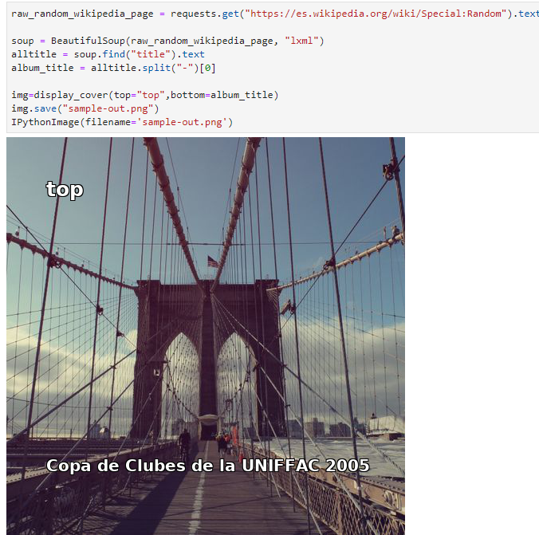

**Question 5:** Finally, you will use the function **display_cover** to print out the album cover with two random article titles representing the name of the band and the title of the album, your screen shot should look something like this:



